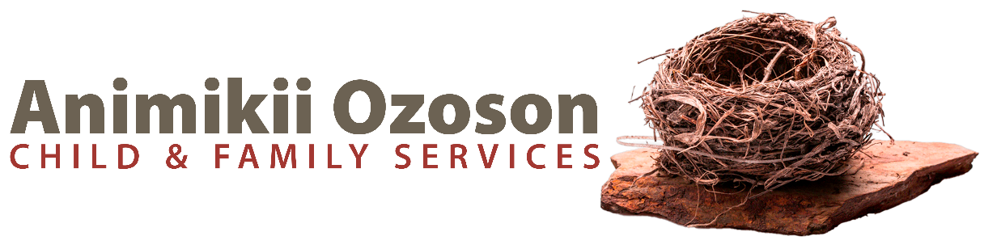
ONTARIO INTAKE CASE MANAGER
Full-Time, Permanent
POSTING #DC01025

AOCFS is responsible for providing mandated services to families and children affiliated with Ontario First Nations communities primarily, but not limited to, Treaty areas 3, 5 and 9, temporarily or permanently living in Manitoba who require child welfare services. We provide crisis response and intake case services, as well as preventative programs and services. AOCFS’ goal is to promote and support the safety and wellbeing of children and families by providing culturally appropriate, strength based, preventative child and family services. AOCFS acknowledges our role in reconciliation as we support the inherent right of Indigenous communities to care for and ensure the wellbeing of their children. Our role as an ongoing service agency is to commit to the calls to action and ensure that we are always acting to end the multigenerational trauma perpetuated by the child welfare system.

Reporting to the unit Supervisor, the incumbent will be responsible for receiving and responding to intakes primarily from First Nation communities and agencies in Ontario. The incumbent will also be responsible for providing general agency intake services.

Responsibilities Include, but are not limited to:
- Screen all referrals for service to determine whether the referral meets the criteria for a child welfare response.
- In consultation, determine the appropriate service stream required to support a family.
- In consultation, determine the appropriate response time required based on immediacy and severity of the potential risk to child(ren).
- Initiate referrals to community collaterals as appropriate, complete written reports, case documentation and correspondence as required.
- If ongoing services are required, complete the Structured Decision Making (SDM) assessment tools and Authority Determination Protocol (ADP) to refer for ongoing services either within AOCFS or transferred to an external agency.
- Provide brief services to families which may include assisting a family short term with basic needs, advocacy, or referrals.
- Provide case management intake coverage for the agency and responds to services requests to assist, or in the absence of the ongoing case manager.
- Ensure service compliance with existing First Nation community customary law, and Federal and Provincial legislation.
- Work professionally and collaboratively with Ontario First Nations agencies, communities, and leaders.
- Assist families to implement the time limited, goal-oriented, case plan while utilizing a range of interventions involving individuals, family, or group approaches.
- Provide brief services to families which may include assisting a family short term with basic needs, advocacy, or referrals.
- Work collaboratively with community resources to facilitate supportive services for families and children.
- Utilize a strength-based approach to engage and work with families to address their needs and build on the strength of the family unit.
- Review and/or revise case plans with families as required.
- Completes all assessments, file recording, record keeping, statistics and other required administrative duties.
- Attend/participate in unit/general staff meetings and assist with functions held by the agency.

Qualifications:
  - Bachelor of Social Work degree (an equivalent combination of education and experience may be considered)
  - Minimum of one-year direct experience in a mandated child and family agency
  - Applicants must be eligible for registration with the Manitoba College of Social Workers
  - Demonstrated ability to work in a fast-paced environment with competing demands
  - Knowledge of, and ability to apply, Indigenous approaches in working with families and children
  - CFSIS/IM experience is an asset
  - Computer literacy in Microsoft Office applications, email and use of the Internet
- A valid Class 5 Manitoba Driver’s License with access to a safe, reliable vehicle as the position requires travel within the city and to Ontario First Nations

The ability to speak Ojibwe is considered a definite asset. Preference will be given to Indigenous people and applicants are asked to self-declare in their cover letter along with describing how they meet the above qualifications.

Qualified SP3/SP4 Candidate’s Salary: $58,133 - $88,911. This permanent position is eligible for our full benefits package which includes health, dental, pension, parking, Paid Time Off Program, and Agency paid MCSW fees

The closing date for all applications is Monday, January 12th 2026 at 4:30pm

Please indicate the POSTING #DC01025 in your cover letter and email subject line

Please forward your resume and cover letter to:
Email: hr@animikiicfs.org
Animikii Ozoson Child & Family Services

We thank all who apply, however only those selected for an interview will be contacted

AOCFS welcomes applications from people with disabilities and will provide accessibility accommodations as part of the application process upon request

